**PS – LAB 08**

**IT24101392 – Wickramasekera J.K.A.D.N**

**Question 01**

**Question 02**

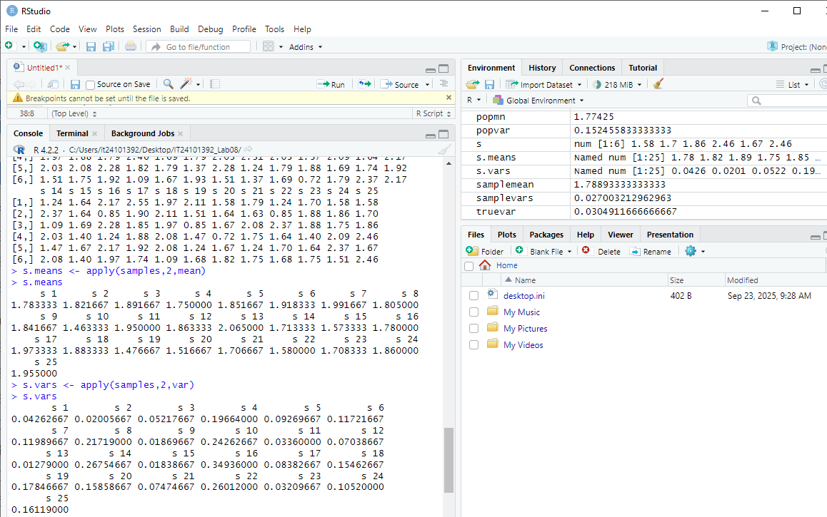

**Question 03**

